How to Complete the Portfolio of Evidence Documentation

 | Page/s | To Do
1. | Pages 2 to 17 | Initial at the bottom of each page
2. | Pages 2 | Leave blank
3. | Pages 3 | Leave blank
4. | Page 4, 5 and 6 | Read
5. | Page 7 and 8 | Leave blank.
6. | Page 9 | Leave blank
7. | Page 10 | Write learner's name and surname.  Sign as a learner where indicated and leave the date field blank.
8. | Page 11 | Write learner's name and surname.  Sign as a learner where indicated and leave the date field blank.
9. | Page 12 | Leave blank
10. | Page 13 | Complete only learner information and ID number.
11 | Page 14 | Leave blank
12. | Page 15 | Leave blank
13. | Page 16 | Leave blank
14. | Page 17 | Leave blank
15. |  | Upload the complete document on the LMS link.

Marksheet – Assessor to Complete in Detail
Critical Cross-fields |  | Competent/ Not Yet Competent | Assessor Comments - detailed
Identifying
Organizing
Collecting
Communicating
Demonstrating
Contributing
Assessor Signature |  |  |  | Date
Moderator Signature |  |  |  | Date

Assessment Decision
OVERALL ASSESSMENT SCORE
- Meets all the criteria for all the specific outcomes of the unit standard.
- Meet some, but not all the criteria for the specific outcomes of the unit standard.
- Clearly do not meet the criteria for the specific outcomes of the unit standard.
- More evidence is required to make a judgement of competence.

VACS Analysis
 | Assessor Name
 | Assessment Evaluated
 | Date of Evaluation
 |  | PRINCIPLE |  |  |  | ASSESSOR REPORT |  | MODERATOR REPORT
Validity of evidence |  | Is the evidence appropriate and related to the specific outcomes? |  | Y/N |  | Yes |  | Yes
 |  | Was there any evidence that prohibited the learner from meeting the assessment criteria? |  | Y/N |  | No |  | No
Authenticity of evidence |  | Is there proof that the evidence is the learner’s own work? |  | Y/N |  | Yes |  | Yes
Currency of evidence |  | Currency refers to the applicability of skills, knowledge and understanding in the present circumstances. Is the evidence current to the situation? |  | Y/N |  | Yes |  | Yes
Sufficiency of evidence |  | Is there enough evidence to meet all the criteria of the specific outcome to certify competency? |  | Y/N |  | Yes |  | Yes
 |  | Will the learner be deemed competent if the learner’s performance is to be reported? |  | Y/N |  | Yes |  | Yes
 | Moderator Signature |  |  |  | Date
 | Assessor Signature |  |  |  | Date

Re-Assessment and Appeal Procedure
Learner completes the re-assessment and appeals application and delivers to the assessor
Assessor decides on actions to be taken:
- Discuss reasons and appropriate actions with learner
- Learner accepts and follows actions
- Assessor re-assess
Assessor or learner still not satisfied
- Appeals application together with actions taken and complete assessment portfolio to the internal moderator
Internal moderator discusses with assessor and learner together next steps and recommendations
- Re-assessment by moderator
Learner still not satisfied with results
- Appeals application, actions taken and complete assessment portfolio to the ETQA for verification
The assessor must provide the moderator with all appeals and re-assessment applications regardless of if the learner accepts the results of the re-assessment or not.
Reassessment should comply with the following conditions:
- Reassessment should take place in the same situation or context and under the same conditions
- The same method and assessment instrument may be used, but the task and materials should be changed. However, they should be of the same complexity and level as the previous one(s).
- Where the methods and instruments are changed, they must be appropriate for the outcomes specified.
- On Appeal the learner must complete and sign the appeals application (see appendix B)
- On reassessment the initial assessment plan should be extended and accepted by the learner.

Note:
Where several outcomes have been assessed and some, but not all, were achieved successfully, a decision must be made about the credits for the successful outcomes, i.e., will the learner be able to retain these credits without having to be reassessed? If so, what would the assessment consist of then?
Care should be taken regarding how often reassessment can be taken, and the length of time between the original assessment and the reassessment. At the initial discussion of the assessment process and appeals procedure the learner and assessor agree on the number of re-assessments. A learner who is repeatedly unsuccessful should be given guidance on other possible and more suitable learning avenues.
Learners should be secure in the knowledge that they can appeal against an unfair assessment.
Appeals can be brought against:
- Unfair assessment
- Invalid assessments
- Unreliable assessments
- The assessor’s judgment, if considered biased
- Inadequate expertise and experience of the assessor if it influenced the assessment.
- Unethical practices.

Appeals Procedure
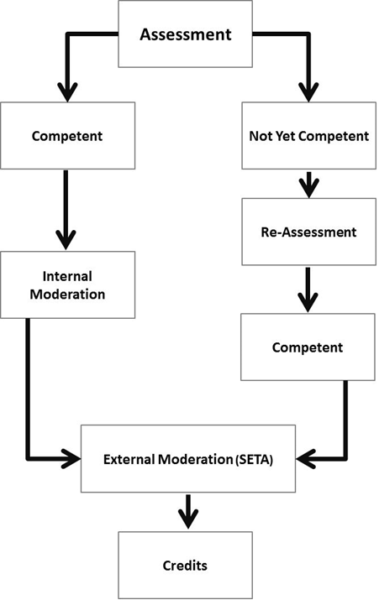

Appeals Application
Unit Standard Title |  | Unit Standard number
NQF level |  | Credits
Venue |  | Date
Learner Name |  | Learner ID number
Assessor Name and Surname |  | Assessor Registration number
1. Please explain how you were assessed:
2. Please list the reason(s) for your appeal:
3. Please indicate what course of action you would find acceptable to resolve this issue. (For example, another assessor, a different assessment method, etc.)
4. Please specify any additional requirements or needs you may have:

Learner  Signature |  | Date
Moderator  Signature |  | Date

Assessor Feedback to learner
Assessor Declaration of Competence |  | 1st Attempt |  |  | 2nd Attempt |  |  |  | 3rd Attempt
 |  | Competent | NYC |  | Competent |  | NYC |  | Competent |  | NYC
Date of declaration
Feedback
Action Plan for Competence and Re-assessment
The learner was assessed on the following date:

The learner has not submitted sufficient evidence and is therefore not yet competent.
The learner is required to submit additional evidence against the following:  (List the specific outcome and assessment criteria relevant below) |  |  |  | The learner is required to improve in the following areas:
Learner Declaration | I, ………………………………………………………………. declare that I am satisfied that the feedback given to me by the Assessor was relevant, sufficient, and done in a constructive manner. I accept the assessment judgment and have no further questions relating to this assessment instrument.
Learner’s Signature |  |  |  |  |  | Date:
Assessor’s Signature |  |  |  |  |  | Date:
Moderator’s Signature |  |  |  |  |  | Date:

Learner: Assessment Review
Learner name
Assessor name
Date of assessment
Question |  |  |  |  | Yes | No
Was the assessment process explained to you before the assessment?
Did the assessor have a pre-assessment meeting with you?
Did you receive feedback after the assessment?
Was the assessment feedback clear enough?
Did you receive your feedback within the agreed Timeframes?
Do you feel that the assessment was fair?
Do you feel that you received enough opportunities during the assessment to provide evidence to the assessor?
Did the assessor explain all the evidence requirements to you?
Were you given the chance to give your input in terms of the assessment process?
Was the evidence judged in accordance with the requirements outlined to you?
Was the feedback provided constructive?
Was the assessment documentation clear and user-friendly?
Learner Signature |  |  | Date
Assessor Signature |  |  | Date
Moderator Signature |  |  | Date

Assessor: Assessment Review
Assessor name
Date of assessment
Assessment Review |  |  |  | Agree |  | Disagree
The learner provided inputs into the assessment process.
Before the assessment was conducted the learner understood what criteria and evidence will be used in the assessment process.
The assessment process was conducted in the learner’s work environment.
The assessment instruments were clear and easily understood by the assessor.
In similar circumstances the assessor will make the same judgment again.
The evidence requirements are relevant to the unit standards.
The evidence identified for this portfolio is sufficient.
The evidence produced by the learner can be verified as being authentic.
The assessment methods are suitable for the outcomes being assessed.
The assessment does not present any barriers for the learner.
All special needs have catered for and considered during the assessment.
The assessment instruments were manageable and user-friendly.
General Comments:
Assessor Signature |  |  | Date
Moderator Signature |  |  | Date

Assessment Review Report of assessor
Unit Standard Title |  | Unit Standard Number
NQF Level |  | Credits
Venue |  | Date
Learner Name |  | Learner ID Number
Assessor Name |  | Assessor Registration Number
Assessment Guide
Strengths
The assessment guide is user friendly and easy to manage.
Weaknesses:
None.
Recommendations:
None.
Assessment Process
Strengths
The process is according to the principles of assessment.
Weaknesses:
None.
Recommendations:
None.

Assessment Methods Used
Strengths
The assessment methods address the assessment criteria of the unit standards and is open and fair.
Weaknesses:
None.
Recommendations:
None.
Assessment Instruments Used
Strengths
Easy manageable, cost effective and gives the learner a fair opportunity to proof competence.
Weaknesses:
None.
Recommendations:
None.
Learner's Readiness for Assessment
Strengths
The learners attended the pre-assessment meeting and signed the checklist.
Weaknesses:
None.
Recommendations:
None.

Unit Standard
Strengths
The unit standards give guidance of what is expected from the learners.
Weaknesses:
None.
Recommendations:
None.
Assessor  Signature |  | Date
Moderator  Signature |  | Date

Special Need Assessment
Name of Course:
Date of Course:
Name of Learner:
ID of Learner:
Name of Assessor:

Explanation of special need:

Actions Taken by Assessor to Complete the Assessment:

Learner Competent | YES |  | NO

Reasons If Not Yet Competent:

Learner Signature |  | Date
Assessor Signature |  | Date
Moderator Signature |  | Date

