Formative Exercise 1A

Ritz Carlton Hotel Case Study

Instructions:
Use the handout of the case study of the Ritz Carlton Hotel.
Some organisations excel in pleasing their customers – one of these examples is the Ritz Carlton Hotel in New York, USA.
Summarise the case study on customer services related to the Ritz Carlton.
Use the following two diagrams as guideline of your summary of their strategy:
- Aspects of effective customer service
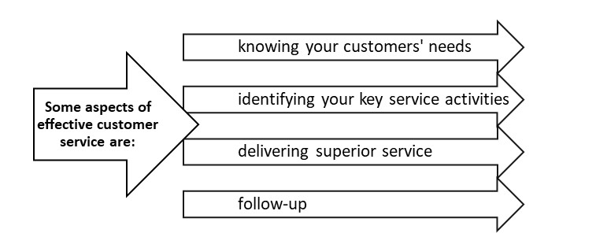
- From the case study, identify any Customer Experience Solutions that the Ritz Carlton Hotel have implemented to add value to their Customer’s experience:
To assist, here is the list of possible CEM solutions:
- The cross-channel (contact center, Internet, self-service, mobile devices, brick and mortar stores),
- Cross-touch point (phone, chat, email, Web, in-person),
- Cross-lifecycle (ordering, fulfillment, billing, support, etc.) nature of the customer experience process.
- From the case study, identify how the Ritz Carlton Hotel align their products and services to their market segment. Use the framework below:
- Segmentation (determine which kinds of customers exist.) Undifferentiated/concentrated/differentiated (underline the correct one). Explain your answer.
- Targeting (select which ones we are best off trying to serve). How well are existing segments served by other manufacturers?
  - How large is the segment, and how can wê expect it to grow?
  - Do the Ritz Carlton have strengths as a company that will help them appeal particularly to one group of consumers?
- Positioning (implement segmentation by optimizing products/services for that segment and communicating the decision). In what market type does the Ritz Carlton Hotel fall. Explain your answer in terms of price, product, distribution and promotion. (like in LG).
How would you categorize the Ritz Carlton Hotel as:
- Operationally Excellent
- Customer Intimate
- Technology Excellent
Explain your answer:

First Attempt |  | Second Attempt |  | Third Attempt
Competent | Not Yet Competent | Competent | Not Yet Competent | Competent | Not Yet Competent

